DOCKER-TASK02
Task 1: Tomcat on port 8080
Step 1: Check Docker
docker --version
sudo systemctl status docker
If Docker is stopped:
sudo systemctl start docker
sudo systemctl enable docker
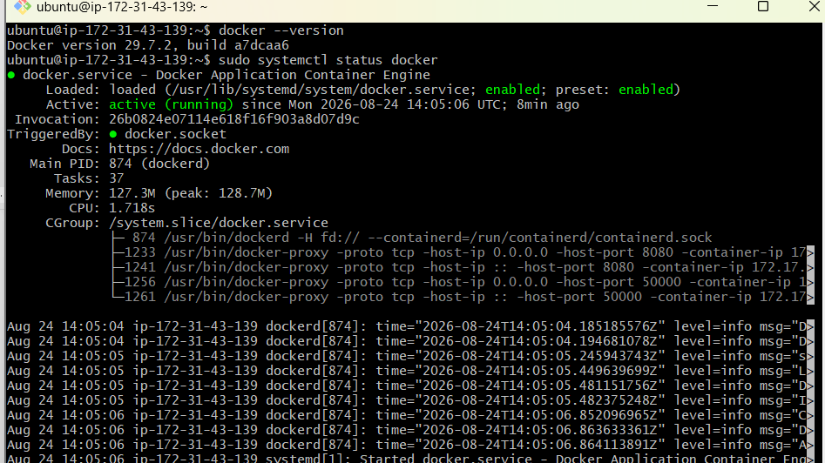
Step 2: Pull the Tomcat image
docker pull tomcat:latest
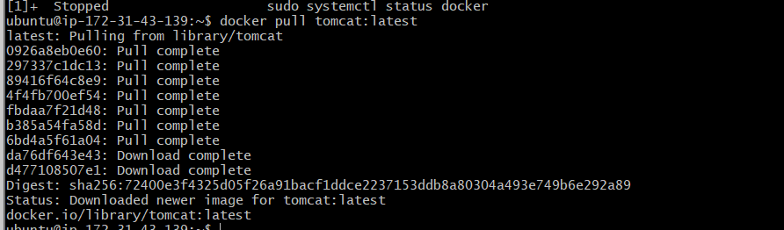
Step 3: Create the sample application
mkdir -p sample-app
cd sample-app
Create an HTML page:
vi index.html
Add:
<!DOCTYPE html>
<html>
<head>
<title>Tomcat Sample Application</title>
</head>
<body>
<h1>Welcome to Tomcat!</h1>
<h2>Sample application deployed successfully.</h2>
</body>
</html>
Save using Esc, :wq, and Enter.
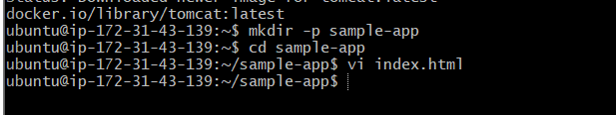
Step 4: Run the Tomcat container
Run this command from inside the sample-app directory:
docker run -d \
--name tomcat-8080 \
-p 8080:8080 \
-v "$(pwd):/usr/local/tomcat/webapps/sample" \
tomcat:latest
Step 5: Verify the container
docker ps
Check the logs:
docker logs tomcat-8080
Test locally:
curl http://localhost:8080/sample/
Open it in your browser:
http://EC2-PUBLIC-IP:8080/sample/
Ensure the EC2 security group allows:
Type: Custom TCP
Port: 8080
Source: My IP
Expected output:
Welcome to Tomcat!
Sample application deployed successfully.
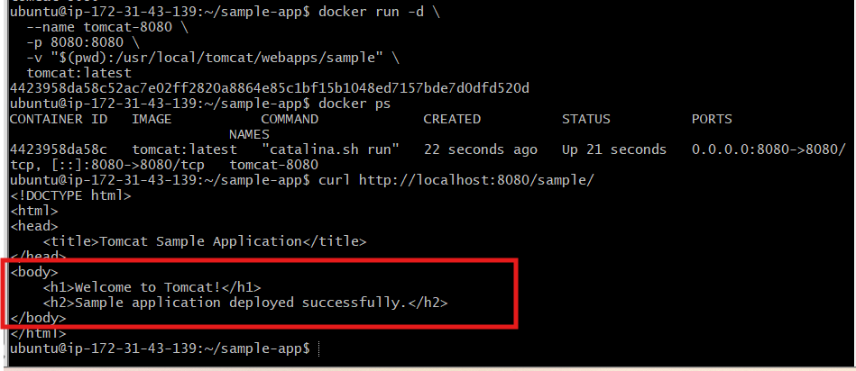

Task 2: Create a volume and run Tomcat on port 8081
Step 1: Create a Docker volume
docker volume create tomcat-volume
Verify:
docker volume ls
Inspect it:
docker volume inspect tomcat-volume
Expected volume name:
tomcat-volume
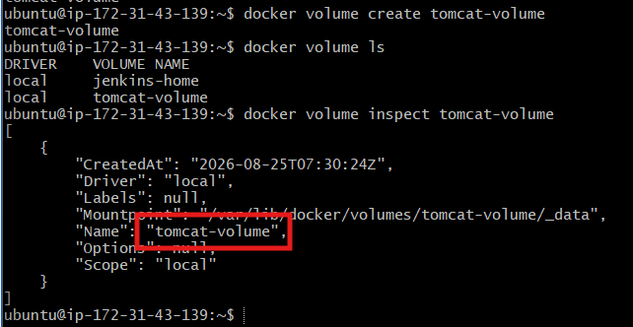
Step 2: Run Tomcat on port 8081
docker run -d \
--name tomcat-8081 \
-p 8081:8080 \
-v tomcat-volume:/usr/local/tomcat/webapps \
tomcat:latest
Port mapping:
EC2 port 8081 → Container port 8080
Verify:
docker ps --filter name=tomcat-8081
Expected port mapping:
0.0.0.0:8081->8080/tcp
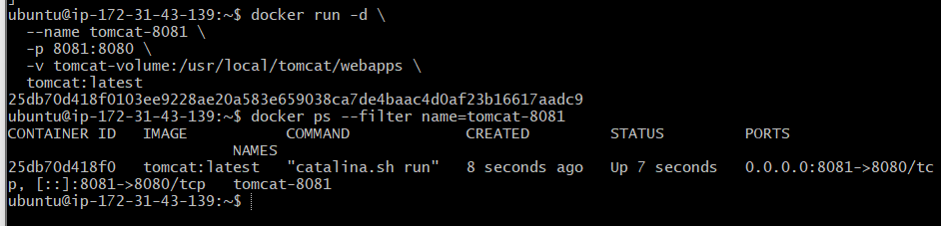
Step 3: Deploy the sample application
You can run these commands from any directory.
Create the application directory inside the volume:
docker exec tomcat-8081 \
mkdir -p /usr/local/tomcat/webapps/sample
Copy the existing index.html:
docker cp ~/sample-app/index.html \
tomcat-8081:/usr/local/tomcat/webapps/sample/index.html
Step 4: Verify the application
docker ps
Test locally:
curl http://localhost:8081/sample/
Browser URL:
http://YOUR-EC2-PUBLIC-IP:8081/sample/
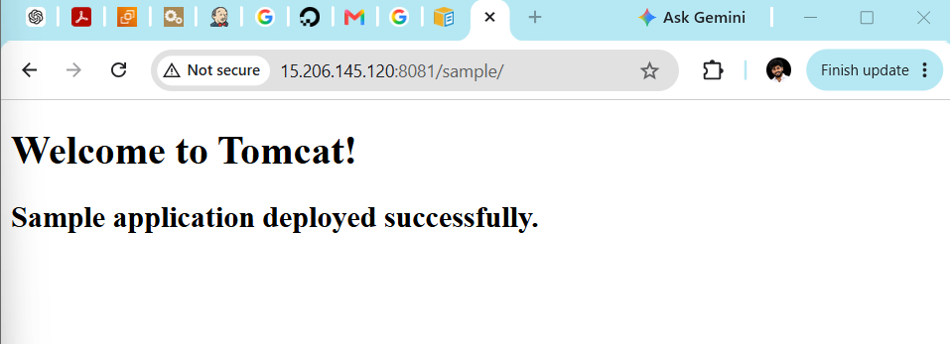
For browser access, add this EC2 security-group inbound rule:
Type: Custom TCP
Port: 8081
Source: My IP
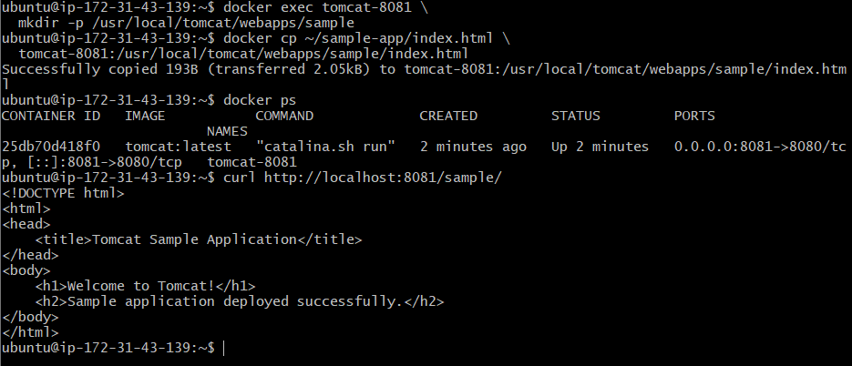
Step 5: Confirm the file is stored in the volume
docker exec tomcat-8081 \
ls -l /usr/local/tomcat/webapps/sample
Expected:
index.html
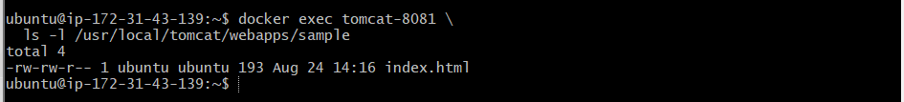

Task 3: Limit the Nginx container to 500 MB
We’ll create an Nginx container with a maximum memory limit of 500 MB.
Step 1: Check existing Nginx containers
docker ps -a --filter ancestor=nginx:latest
Your previous container is named nginx-container, so we’ll use a different name.
Step 2: Run Nginx with a 500 MB limit
docker run -d \
--name nginx-500mb \
-p 82:80 \
--memory="500m" \
--memory-swap="500m" \
nginx:latest
Explanation:
--memory="500m" Maximum RAM: 500 MB
--memory-swap="500m" RAM + swap total: 500 MB
-p 82:80 EC2 port 82 → container port 80
Step 3: Confirm the container is running
docker ps --filter name=nginx-500mb
Expected port mapping:
0.0.0.0:82->80/tcp
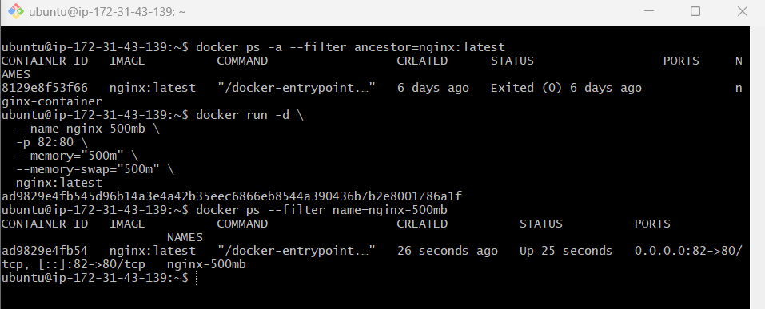
Step 4: Verify the memory limit
docker inspect nginx-500mb \
--format='Memory={{.HostConfig.Memory}} bytes'
Expected:
Memory=524288000 bytes
Check the limit in MB:
docker inspect nginx-500mb \
--format='{{.HostConfig.Memory}}' | awk '{print $1/1024/1024 " MB"}'
Expected:
500 MB
Step 5: Check live usage
docker stats nginx-500mb
You should see a limit close to:
MEM USAGE / LIMIT
... / 500MiB
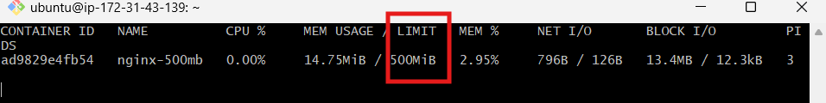
Press Ctrl+C to exit.
Step 6: Test Nginx
curl http://localhost:82
Browser:
http://15.206.145.120:82
For browser access, allow inbound TCP port 82 in the EC2 security group.
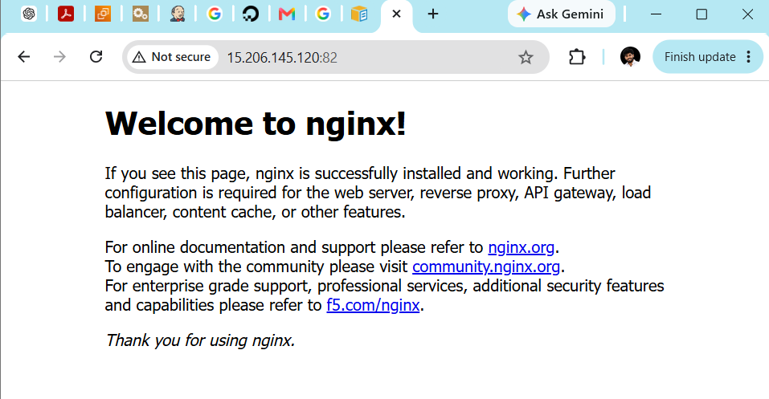
Task 4: Create a custom Nginx image using Dockerfile
We will create a separate directory for this task.
Step 1: Create the project directory
cd ~
mkdir amazonlinux-nginx
cd amazonlinux-nginx
Verify:
pwd
Expected:
/home/ubuntu/amazonlinux-nginx
Step 2: Create index.html
vi index.html
Add:
<!DOCTYPE html>
<html>
<head>
<title>Venu Custom Docker Image</title>
</head>
<body>
<h1>Welcome to Venu's Custom Nginx Image!</h1>
<h2>Built using Amazon Linux and Docker.</h2>
</body>
</html>
Save with:
Esc → :wq → Enter
Step 3: Create the Dockerfile
The filename must be exactly Dockerfile with a capital D and no extension:
vi Dockerfile
Add:
# Base image
FROM amazonlinux:latest
# Image maintainer
LABEL maintainer="Venu Gopal"

# Install Nginx and clean package cache
RUN dnf install -y nginx && \
dnf clean all

# Copy the website into the image
COPY index.html /usr/share/nginx/html/index.html

# Document the container port
EXPOSE 80

# Keep Nginx running in the foreground
CMD ["nginx", "-g", "daemon off;"]
Save and exit.
Step 4: Confirm the files
ls -l
Expected:
Dockerfile
index.html
Review the Dockerfile:
cat Dockerfile
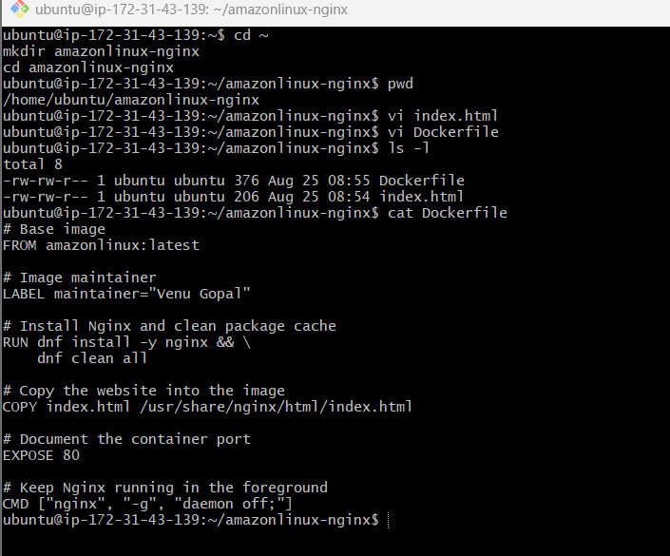
Step 5: Build the custom image
docker build -t venu-amazonlinux-nginx:v1 .
The final . means Docker should use the current directory as the build context.
Verify:
docker images venu-amazonlinux-nginx
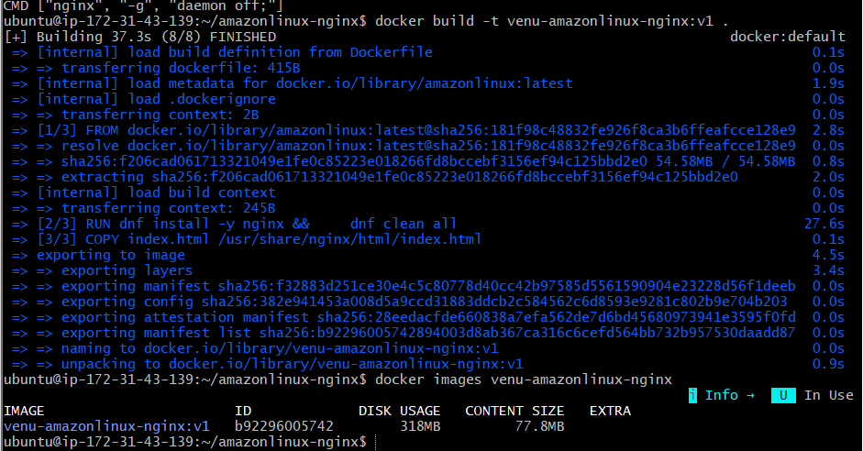
Step 6: Create a container from the image
Use host port 83 because ports 8080, 8081, and 82 are already in use:
docker run -d \
--name custom-nginx \
-p 83:80 \
venu-amazonlinux-nginx:v1
Step 7: Verify the container
docker ps --filter name=custom-nginx
Test locally:
curl http://localhost:83
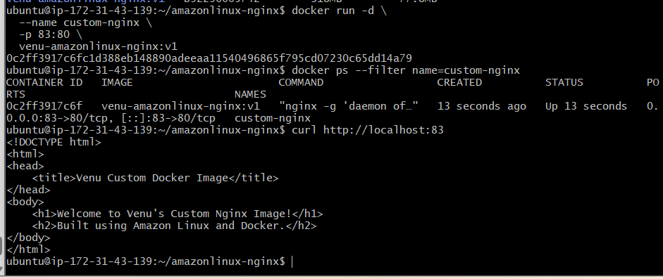
Browser URL:
http://15.206.145.120:83
Allow inbound TCP port 83 in the EC2 security group for browser access.
Expected page:
Welcome to Venu's Custom Nginx Image!
Built using Amazon Linux and Docker.
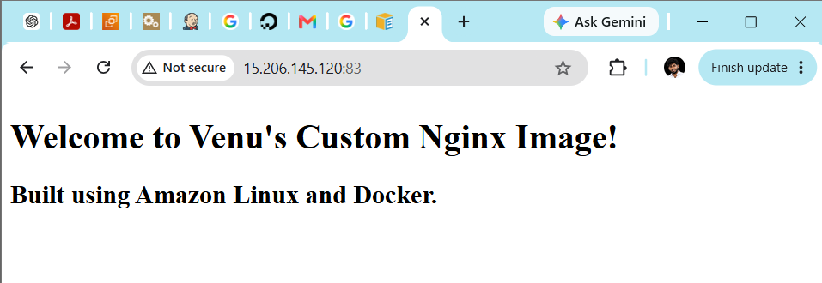

Task 5: Push the custom image to Docker Hub
You need a Docker Hub account and repository.
Step 1: Create a Docker Hub repository
Open Docker Hub and sign in.
Select:
My Hub → Repositories → Create repository
Enter:
Repository name: venu-amazonlinux-nginx
Visibility: Public
Create the repository.
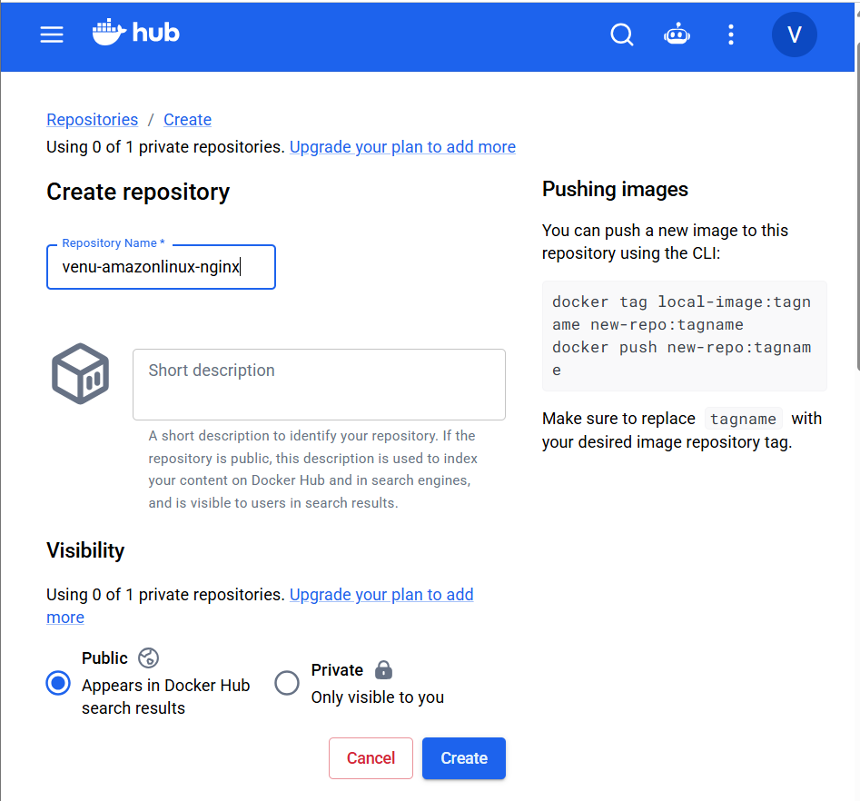
Step 2: Log in from the EC2 server
docker login
Enter:
Username: Your Docker Hub username
Password: Docker Hub personal access token
The password/token will not appear while typing.
For better security, create a token in Docker Hub:
Account Settings → Personal access tokens → Generate new token
Do not share the token here.
Expected:
Login Succeeded
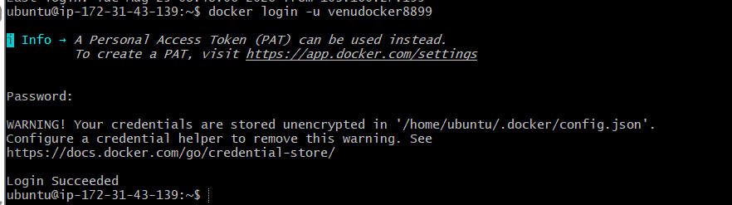
Step 3: Confirm the local image
docker images venu-amazonlinux-nginx
Expected image:
venu-amazonlinux-nginx v1
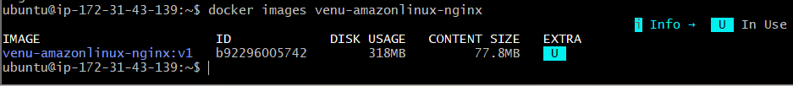
Step 4: Tag the image
Replace YOUR_DOCKERHUB_USERNAME with your actual username:
docker tag venu-amazonlinux-nginx:v1 \
YOUR_DOCKERHUB_USERNAME/venu-amazonlinux-nginx:v1
Example only:
docker tag venu-amazonlinux-nginx:v1 \
venugopal/venu-amazonlinux-nginx:v1
Check the new tag:
docker images | grep venu-amazonlinux-nginx
Both image names may have the same image ID. This is normal because tagging does not create a duplicate image.
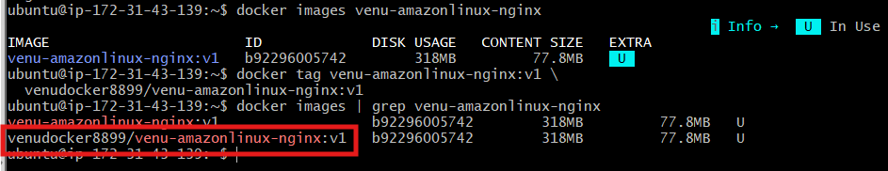
Step 5: Push the image
docker push \
YOUR_DOCKERHUB_USERNAME/venu-amazonlinux-nginx:v1
Expected final output:
v1: digest: sha256:... size: ...
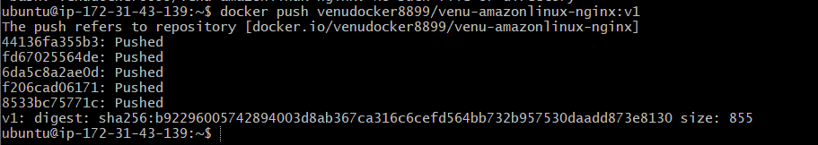
Step 6: Verify
Refresh your Docker Hub repository. The v1 tag should appear.
You can also test it using:
docker pull \
YOUR_DOCKERHUB_USERNAME/venu-amazonlinux-nginx:v1
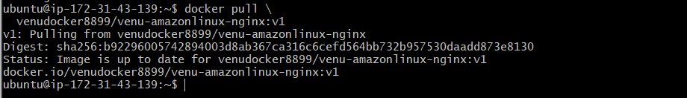

Task 6: Push the image to AWS ECR
First, verify AWS CLI and authentication on your EC2 server.
Step 1: Check AWS CLI
aws –version
Step 2: Check AWS authentication
aws sts get-caller-identity
Expected output contains:
{
"UserId": "...",
"Account": "AWS_ACCOUNT_ID",
"Arn": "..."
}
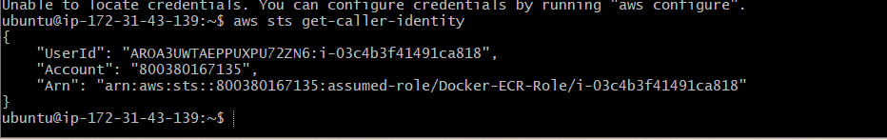
Step 3: Check the configured AWS region
aws configure get region
If it returns nothing, set Mumbai:
aws configure set region ap-south-1
If aws sts get-caller-identity gives a credentials error, the EC2 instance needs either:
- An IAM role with ECR permissions attached to the instance, or
- AWS CLI credentials configured with aws configure.
Run these three commands and share the output, but do not share secret keys:
aws --version
aws sts get-caller-identity
aws configure get region
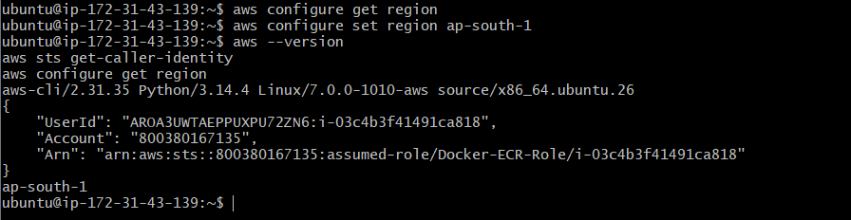
Step 4: Tag the local image for ECR
Run:
docker tag venu-amazonlinux-nginx:v1 \
800380167135.dkr.ecr.ap-south-1.amazonaws.com/venu-amazonlinux-nginx:v1
This adds the ECR repository address to your local image.
Verify:
docker images | grep venu-amazonlinux-nginx
You should see three tags with the same image ID:
venu-amazonlinux-nginx:v1
venudocker8899/venu-amazonlinux-nginx:v1
800380167135.dkr.ecr.ap-south-1.amazonaws.com/venu-amazonlinux-nginx:v1
The same image ID is expected because these are different names for the same image.
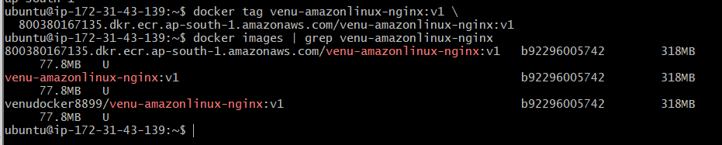
Step 5: Push the image
The image is already tagged, so you do not need to tag it again.
docker push \
800380167135.dkr.ecr.ap-south-1.amazonaws.com/venu-amazonlinux-nginx:v1
Expected final output:
v1: digest: sha256:... size: ...
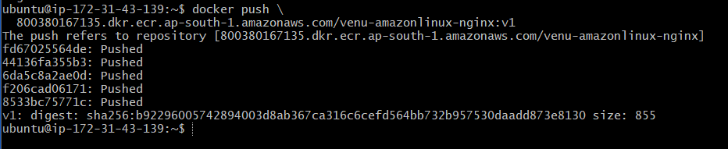
Step 6: Verify using AWS CLI
Detailed output:
aws ecr describe-images \
--repository-name venu-amazonlinux-nginx \
--region ap-south-1
Look for:
"imageTags": [
"v1"
]
For shorter output:
aws ecr list-images \
--repository-name venu-amazonlinux-nginx \
--region ap-south-1
Expected:
{
"imageIds": [
{
"imageDigest": "sha256:...",
"imageTag": "v1"
}
]
}
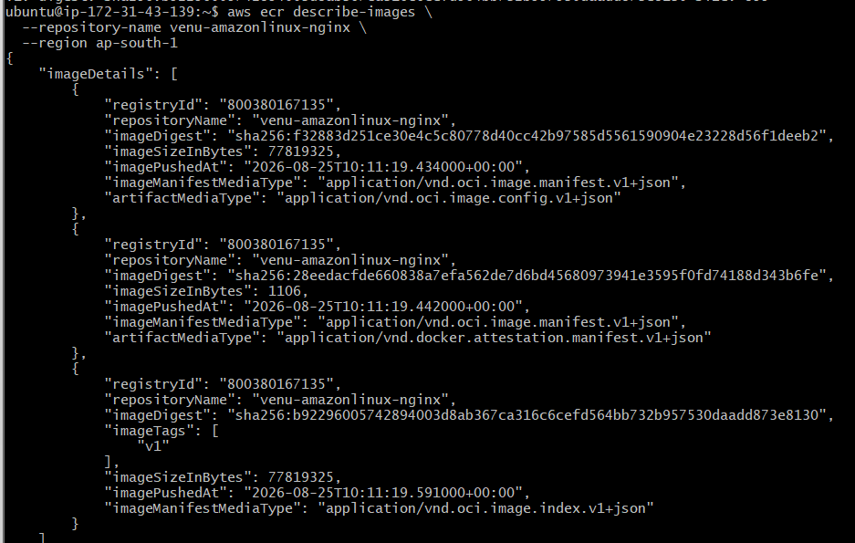
Step 7: Verify in AWS Console
Open:
AWS Console
→ Elastic Container Registry (ECR)
→ Private registry
→ Repositories
→ venu-amazonlinux-nginx
→ Images
You should see:
Image tag: v1
Correct flow:
Repository created ✅ → ECR login → Push image → Verify image
